Name: R Saiharsha
Reg No: 192372157
Course Code: CSA1302
Course Name: Theory Of Computation

1. Write a C program to check whether a given string belongs to the language defined by a Context Free Grammar (CFG)
S-0A1
A0A 1A ε

C Program:
#include <stdio.h>
#include <string.h>

int main()
{
char str[100];
int i, len, valid = 1;

printf("Enter a string: ");
scanf("%s", str);

len = strlen(str);

// S -> 0A1
// So first character must be 0
// Last character must be 1

if (str[0] != '0' || str[len - 1] != '1')
{
valid = 0;
}

// A -> 0A | 1A | ε
// Therefore middle characters can be 0 or 1
for (i = 0; i < len; i++)
{
if (str[i] != '0' && str[i] != '1')
{
valid = 0;
break;
}
}

if (valid)
printf("String belongs to the language\n");
else
printf("String does NOT belong to the language\n");

return 0;
}
Output:
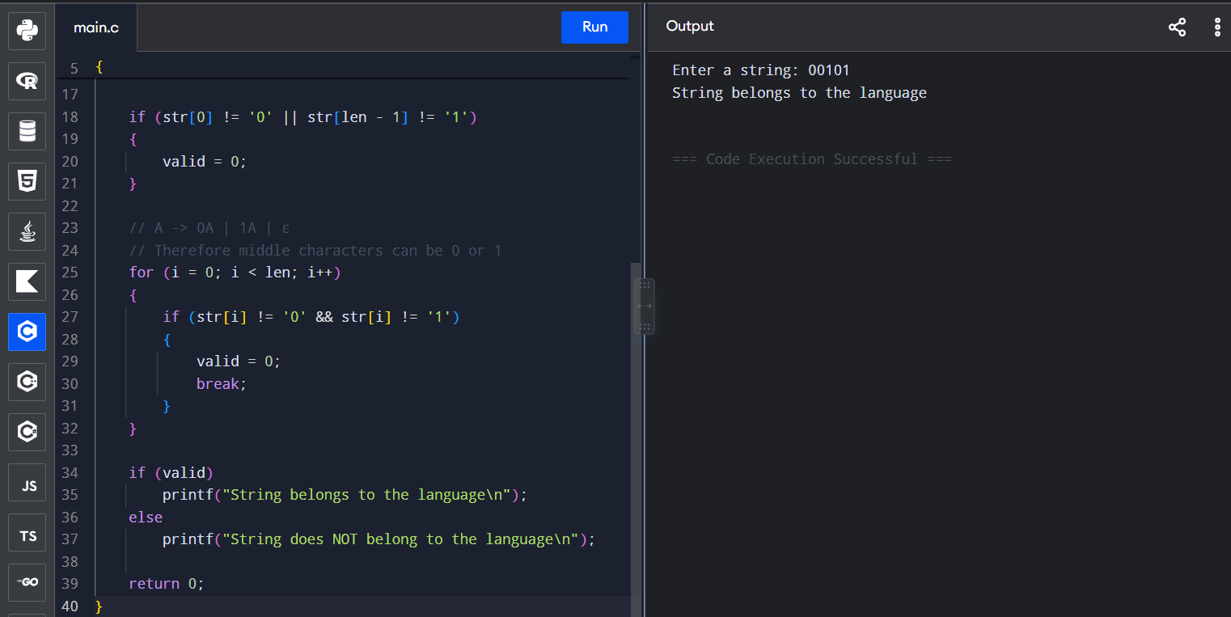

✅ Valid Input
Enter a string: 00101
String belongs to the language
Reason: Starts with 0 and ends with 1.

❌ Invalid Input
Enter a string: 1010
String does NOT belong to the language

2.Write a C program to check whether a given string belongs to the language defined by a Context Free Grammar (CFG)
S0S0
| 1S1 |
0 | 1 | ε

C Program:

#include <stdio.h>
#include <string.h>

char str[100];

int palindrome(int left, int right)
{
if (left > right)
return 1; // S -> ε

if (left == right)
return 1; // S -> 0 or 1

if (str[left] == str[right])
return palindrome(left + 1, right - 1);

return 0;
}

int main()
{
printf("Enter a string: ");
scanf("%s", str);

if (palindrome(0, strlen(str) - 1))
printf("String belongs to the language\n");
else
printf("String does NOT belong to the language\n");

return 0;
}

Output:
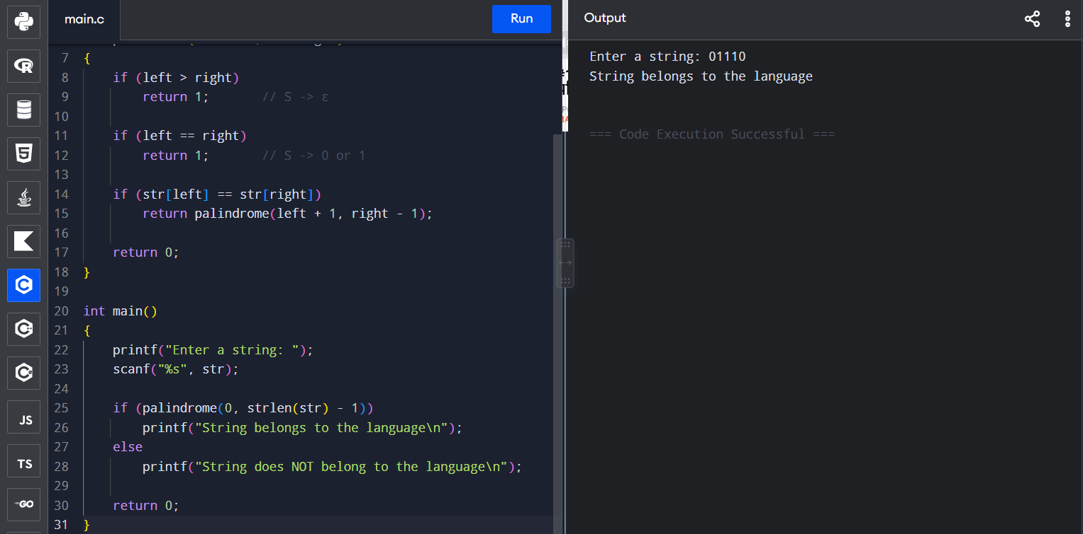

✅ Valid Input
Enter a string: 0110
String belongs to the language
Reason: 0110 is a palindrome.

❌ Invalid Input
Enter a string: 0101
String does NOT belong to the language
Because reverse of 0101 is 1010.

3.Write a C program to check whether a given string belongs to the language defined by a Context Free Grammar (CFG)
S → OSO | A
A - 1A | ε

C Program:
#include <stdio.h>
#include <string.h>

char str[100];
int pos, len;

int check()
{
int leftZeros = 0;
int rightZeros = 0;
int ones = 0;

/* Count starting 0s */
while (pos < len && str[pos] == '0')
{
leftZeros++;
pos++;
}

/* Count middle 1s */
while (pos < len && str[pos] == '1')
{
ones++;
pos++;
}

/* Count ending 0s */
while (pos < len && str[pos] == '0')
{
rightZeros++;
pos++;
}

if (pos == len && leftZeros == rightZeros)
return 1;

return 0;
}

int main()
{
printf("Enter a string: ");
scanf("%s", str);

pos = 0;
len = strlen(str);

if (check())
printf("String belongs to the language\n");
else
printf("String does NOT belong to the language\n");

return 0;
}

Ouput:
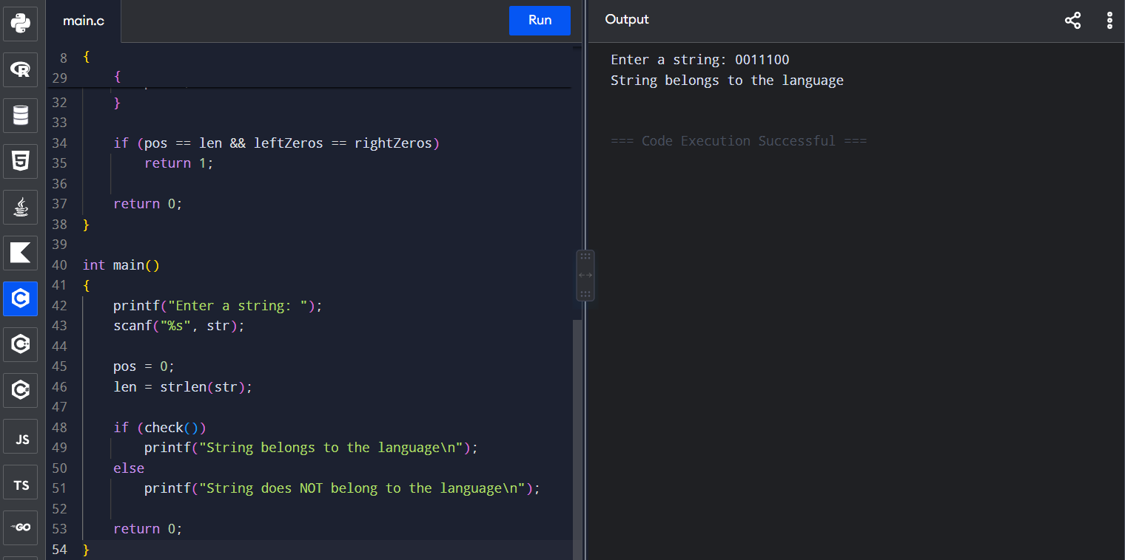

✅ Valid Input
Enter a string: 0011100
String belongs to the language
Here:
00 111 00
↑ ↑
2 zeros 2 zeros

❌ Invalid Input
Enter a string: 001110
String does NOT belong to the language
Because starting 0s = 2, ending 0s = 1.

4. Write a C program to check whether a given string belongs to the language defined by a Context Free Grammar (CFG)
S - OS1 | ε

C Program:

#include <stdio.h>
#include <string.h>

int main()
{
char str[100];
int i, len;
int zeros = 0, ones = 0;
int valid = 1;

printf("Enter a string: ");
scanf("%s", str);

len = strlen(str);

// Count 0s from the beginning
for (i = 0; i < len && str[i] == '0'; i++)
{
zeros++;
}

// Count 1s after all 0s
for (; i < len && str[i] == '1'; i++)
{
ones++;
}

// If any characters are left, pattern is wrong
if (i != len)
{
valid = 0;
}

// Number of 0s and 1s must be equal
if (zeros != ones)
{
valid = 0;
}

if (valid)
printf("String belongs to the language\n");
else
printf("String does NOT belong to the language\n");

return 0;
}

Ouput:

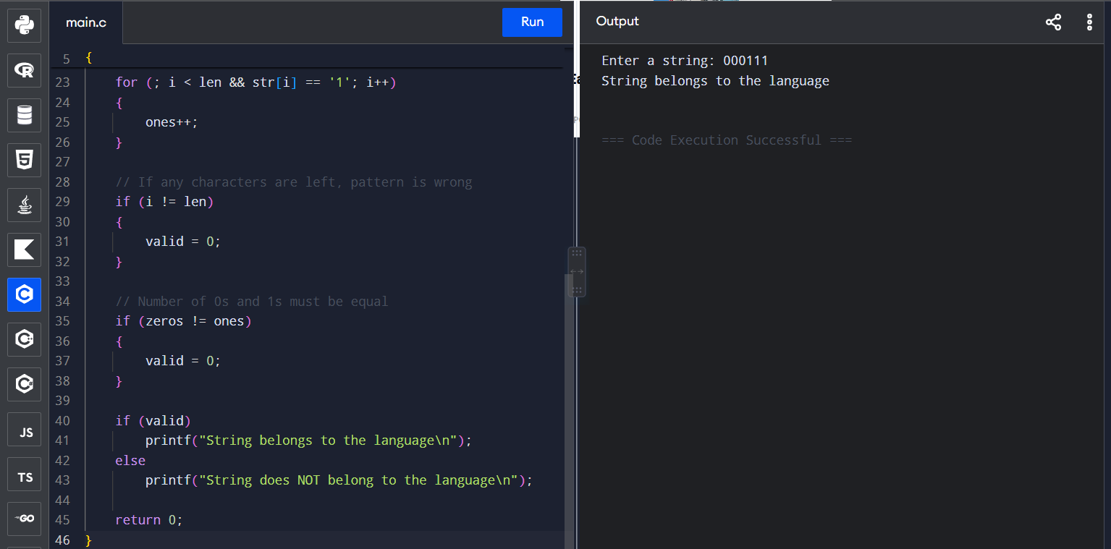

✅ Valid Input
Enter a string: 000111
String belongs to the language
Because:
000 → 3 zeros
111 → 3 ones

❌ Invalid Input
Enter a string: 00111
String does NOT belong to the language
Because:
00 → 2 zeros
111 → 3 ones

5.Write a C program to check whether a given string belongs to the language defined by a Context Free Grammar (CFG)
S → A101A
Α → 0A | 1A | ε

C Program:

#include <stdio.h>
#include <string.h>

int main()
{
char str[100];
int i, found = 0;

printf("Enter a string: ");
scanf("%s", str);

for (i = 0; str[i] != '\0'; i++)
{
if (str[i] == '1' &&
str[i + 1] == '0' &&
str[i + 2] == '1')
{
found = 1;
break;
}
}

if (found)
printf("String belongs to the language\n");
else
printf("String does NOT belong to the language\n");

return 0;
}

Output:
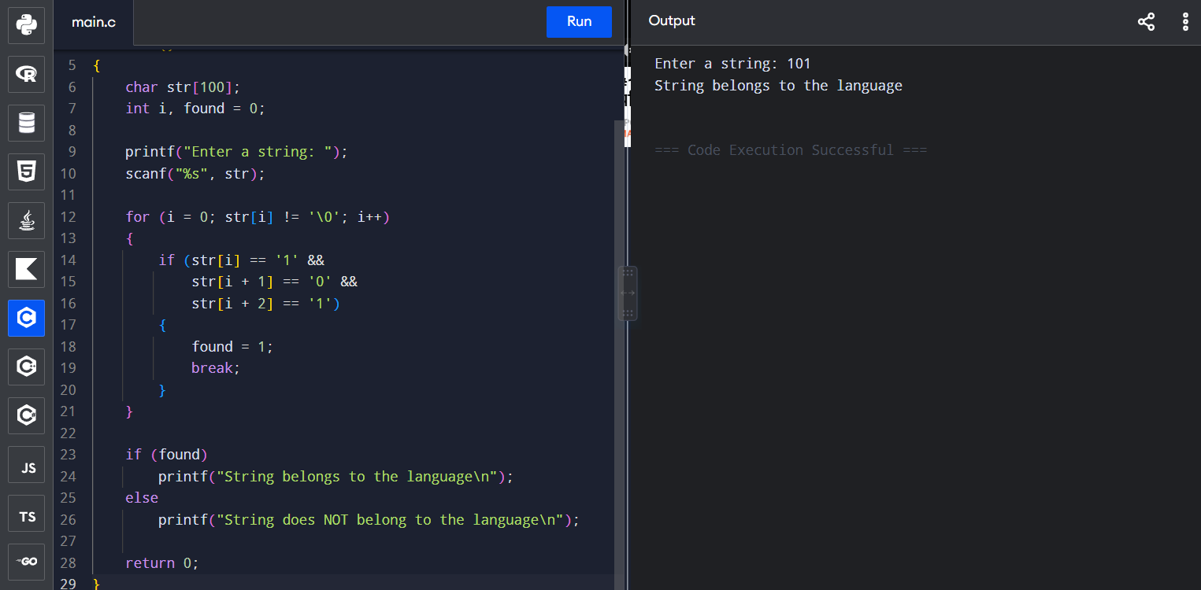

✅ Valid Input
Enter a string: 110101
String belongs to the language
Because it contains:
110101
↑
101
❌ Invalid Input
Enter a string: 110011
String does NOT belong to the language
Because 101 is not present.

